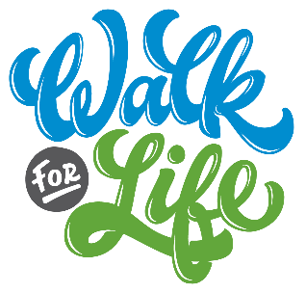

Suggested Bulletin, Email, and Website Announcements

APRIL 28 Support the ministry of Life Network and the Colorado Springs Pregnancy Center – begin fundraising and join us June 3 for Life Network’s Walk for Life! The funds you raise for the Walk will make a difference in the lives of babies, moms, dads, students and families. Join thousands of your Colorado Springs neighbors to walk together at Memorial Park. Visit www.WalkForLife.com to register and build your easy online fundraising page! Our goal is _______ fundraising walkers from our church – will you join us?

May 5 You can make a difference for local moms this Mother’s Day! Join us to participate in Life Network’s 37th Annual Walk for Life on Saturday, June 1. This event provides funds for the ministry of Life Network and the Colorado Springs Pregnancy Center, empowering moms facing unplanned pregnancies and supporting them in their motherhood. Our goal is [number] fundraising walkers from our church. Visit www.WalkForLife.com to register and build your easy online fundraising page!

May 12 CALLING ALL SMALL GROUPS! Walk as a team for Life Network’s Walk for Life on Saturday, June 1. You and your team can meet to walk together at this exciting life-affirming event at Memorial Park. Give yourselves a team name and start asking people to sponsor you – making a difference in the life of an preborn child really is that easy! Visit www.WalkForLife.com to register and build your easy online fundraising page – and create your team at the same time!

May 19 Go the extra mile for a baby! Participate in Life Network’s 37th Annual Walk for Life on Saturday, June 1 at Memorial Park! Last year over 2,000 walkers went the “extra mile” and raised funds for Life Network and the Colorado Springs Pregnancy Center, helping to reach over 15,000 individuals in our community. Our goal is [number] fundraising walkers from our church – will you join us? Visit www.WalkForLife.com to register and build your easy online fundraising page!

May 26 Life Network’s Walk for Life is this Saturday! Join our community THIS Saturday, June 1 to support the life-saving work of Life Network and the Colorado Springs Pregnancy Center. Join us at Memorial Park as we walk together to value life as a church family. Every $150 you raise will provide free support services for 3 clients and their babies. Visit www.WalkForLife.com to register and build your easy online fundraising page!

