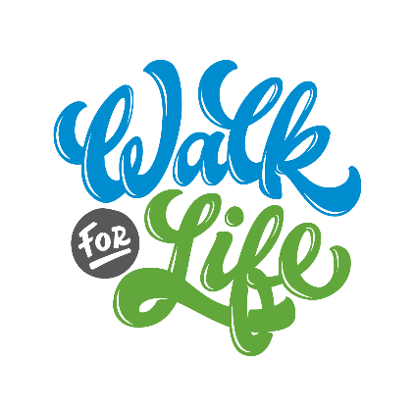
Sign up to join your church and make a difference in the lives of moms, dads, babies, and students through the
2023 Walk for Life!
Our Goal:
#___________
Fundraisers!

# | Name | Phone | Email | I will be…
____ Walking ____ Running
____ Other:
____ Walking ____ Running
____ Other:
____ Walking ____ Running
____ Other:
____ Walking ____ Running
____ Other:
____ Walking ____ Running
____ Other:
____ Walking ____ Running
____ Other:
____ Walking ____ Running
____ Other:
____ Walking ____ Running
____ Other:
____ Walking ____ Running
____ Other:
____ Walking ____ Running
____ Other:
____ Walking ____ Running
____ Other:
____ Walking ____ Running
____ Other:

____ Walking ____ Running
____ Other:
____ Walking ____ Running
____ Other:
____ Walking ____ Running
____ Other:
____ Walking ____ Running
____ Other:
____ Walking ____ Running
____ Other:
____ Walking ____ Running
____ Other:
____ Walking ____ Running
____ Other:
____ Walking ____ Running
____ Other:

