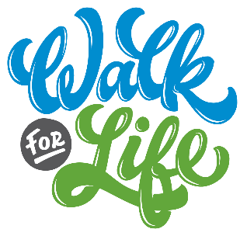

Suggested Bulletin, Email, and Website Announcements

May 1st Support the ministry of Life Network and the Colorado Springs Pregnancy Center – begin fundraising and join us June 4th for Life Network’s Walk for Life! The funds you raise for the Walk will make a difference in the lives of babies, moms, dads, students and families. Join thousands of your Colorado Springs neighbors to walk together at Memorial Park. Visit www.WalkForLife.com to register and build your easy online fundraising page! Our goal is [number] fundraising walkers from our church – will you join us?

May 8th You can make a difference for local moms this Mother’s Day! Join us to participate in Life Network’s 35th Annual Walk for Life on Saturday, June 4th. This event provides funds for the ministry of Life Network and the Colorado Springs Pregnancy Center, empowering moms facing unplanned pregnancies and supporting them in their motherhood. Our goal is [number] fundraising walkers from our church. Visit www.WalkForLife.com to register and build your easy online fundraising page!

May 15th CALLING ALL SMALL GROUPS! Walk as a team for Life Network’s Walk for Life on Saturday, June 4th. You and your team can meet to walk together at this exciting life-affirming event at Memorial Park. Give yourselves a team name and start asking people to sponsor you – making a difference in the life of an unborn child really is that easy! Visit www.WalkForLife.com to register and build your easy online fundraising page – and create your team at the same time!

May 22nd Go the extra mile for a baby! Participate in Life Network’s 35th Annual Walk for Life on Saturday, June 4th at Memorial Park! Last year over 800 walkers went the “extra mile” and raised funds for Life Network and the Colorado Springs Pregnancy Center, helping to reach over 15,000 individuals in our community. Our goal is [number] fundraising walkers from our church – will you join us? Visit www.WalkForLife.com to register and build your easy online fundraising page!

May 29th Life Network’s Walk for Life is this Saturday! Join our community THIS Saturday, June 4th to support the life-saving work of Life Network and the Colorado Springs Pregnancy Center. Join us at Memorial Park as we walk together to value life as a church family. Every $150 you raise will provide free support services for 3 clients and their babies. Visit www.WalkForLife.com to register and build your easy online fundraising page!

