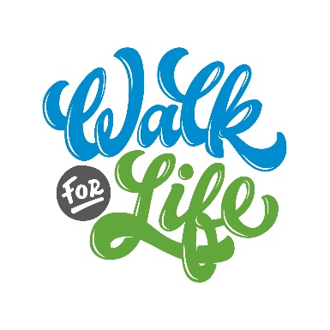
Sample Captions for Social Media Posts
General Captions
- Life Network exists to serve the families of Colorado Springs and promote life in our community. Over the next few weeks I will be raising funds to help them continue the work they are doing. Would you consider sponsoring me as I walk for life? [FundEasy page link]*
- This June, I am walking for life because [insert your personal reason here]. While this year’s Walk for Life may look a little different with social distancing, the families that Life Network serves in our city need our support now more than ever! Join me as I walk for life through a sponsorship donation so that families in our city can receive compassionate care and resources, especially in the midst of uncertainty. Your generosity can make such a difference! [FundEasy page link]
- I walk for life because I believe every life is a gift from God. Life Network exists to cultivate a community that values life through the love of Christ – right here in Colorado Springs. Would you join me by sponsoring me as I walk for life? [FundEasy page link]
- This June, I am walking for life and raising funds for Life Network because I want to see every teen in Colorado Springs make healthy relationship choices and know they are needed, loved and valued. Would you consider sponsoring me as I walk for life? [FundEasy page link]
- This June, I am walking for life and raising funds for Life Network because I want to see every post-abortive woman find healing and restoration. Would you consider sponsoring me as I walk for life? [FundEasy page link]
- This June, I am walking for life and raising funds for Life Network because I want to see more women in our community given the confidence they need to know they’ll be supported in their pregnancy. [FundEasy page link]
- This June, I am walking for life and raising funds for Life Network so that new moms and dads in our community can become empowered in their life-affirming decisions for their families. Life Network makes this possible through one-on-one parenting education and coaching, giving new parents the confidence they need to be the best parents they can be. Want to join me in valuing life in our city? Consider sponsoring me as I walk for life! Check out my FundEasy page to donate here: [insert your personal FundEasy page link]*
*Pro Tip: If you’re sharing these captions on Instagram, be sure to put your FundEasy page link in your bio and mention “Link to donate in my bio!” so that your followers and friends can click directly into it! (Instagram does not support direct links in captions).

Other Caption Ideas:
- Share your favorite Bible verse that speaks the truth about life! Our favorites are Psalm 139, Jeremiah 1:5, Psalm 127:3, Job 33:4 and Proverbs 31:8.
- Share a personal story that demonstrates why YOU walk for life.
- Share how you got involved with Life Network and why you think our mission is important.
- Share how your kids are getting involved with fundraising!
- Share updates on your team, your church group or church leaders as you fundraise.

For impactful client stories to share, see the Client Story graphics & corresponding captions on the Resources page of walkforlife.com!

