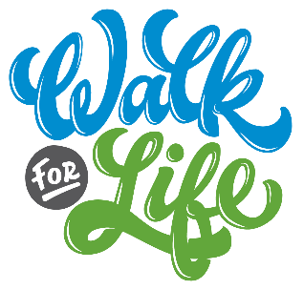

Suggested Bulletin, Email, and Website Announcements

May 3rd Support the ministry of Life Network and the Colorado Springs Pregnancy Center – begin fundraising and join us June 6th for Life Network’s first ever VIRTUAL Walk for Life! The funds you raise for the Walk will make a difference in the life of an unborn child! Given our current public health guidance, we will be celebrating the value of human life city-wide as we walk in our own neighborhoods. There will also be a special live-stream event that Saturday! Visit www.WalkForLife.com to register and build your easy online fundraising page! Our goal is [number] fundraising walkers from our church – will you join us?

May 10th One person can make a difference! Participate in Life Network’s VIRTUAL Walk for Life on Saturday, June 6th. This event provides funds for the ministry of Life Network and the Colorado Springs Pregnancy Center, which serves over 15,000 individuals in our community annually. Our goal is [number] fundraising walkers from our church. Visit www.WalkForLife.com to register and build your easy online fundraising page!

May 17th CALLING ALL SMALL GROUPS! Walk as a team for Life Network’s VIRTUAL Walk for Life on Saturday, June 6th. While we won’t be all walking together this year, you can make plans to walk in your neighborhood with a small group team! Give yourselves a team name and start asking people to sponsor you – making a difference in the life of an unborn child really is that easy! Visit www.WalkForLife.com to register and build your easy online fundraising page – and create your team at the same time!

May 24th Go the extra mile for a baby! Participate in Life Network’s VIRTUAL Walk for Life on Saturday, June 6th! Last year over 600 walkers went the “extra mile” and provided funds for Life Network and the Colorado Springs Pregnancy Center, helping to reach over 15,000 individuals in our community. Our goal is [number] fundraising walkers from our church, walking in our neighborhoods across the city – will you join us? Visit www.WalkForLife.com to register and build your easy online fundraising page!

May 31st Life Network’s VIRTUAL Walk for Life is this Saturday! Join our community THIS Saturday, June 6th to support the life-saving work of Life Network and the Colorado Springs Pregnancy Center. Given our current public health guidance, we will be celebrating the value of human life city-wide as we walk in our own neighborhoods. There will also be a special live-stream event to bring us all together on Saturday! Every $150 you raise will provide free support services for 3 clients and their babies. Visit www.WalkForLife.com to register and build your easy online fundraising page!

