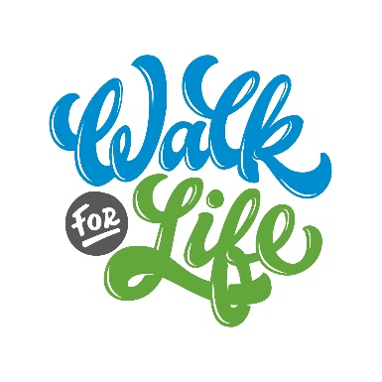
Sample Captions for Social Media Posts
- Life Network exists to serve the families of Colorado Springs and promotes life in our community. Over the next few weeks I will be raising funds to help them continue the work they are doing. Would you consider sponsoring me as I walk for life?
- This June, I am walking and raising funds for mothers like (Quinn, Jamie, or Abby) to be able to have the support and resources they need. Would you consider sponsoring me as I walk for life?
- This June, I am walking for life and raising funds for Life Network because I want to see every teenager in Colorado Springs make healthy relationship choices and know their worth and value. Would you consider sponsoring me as I walk for life?
- This June, I am walking for life and raising funds for Life Network because I want to see every post-abortive woman find healing and restoration. Would you consider sponsoring me as I walk for life?
- This June, I am walking for life and raising funds for Life Network because I want to see more young adults given the confidence they need to know they’ll be supported in their pregnancy.

