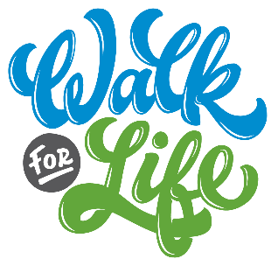

Suggested Bulletin, Email, and Website Announcements

April 29th Be a part of the 31st Annual Walk for Life! Support the ministry of Life Network and the Colorado Springs Pregnancy Center – begin fundraising and join us June 2nd at Memorial Park to make a difference in the life of an unborn child! Get a pledge sheet from the Walk information table [table location] or visit www.WalkForLife.com. Our goal is [number] fundraising walkers from our church – will you join us?

May 6th One person can make a difference! Participate in the 31st Annual Walk for Life on Saturday, June 2nd at Memorial Park. This event provides funds for the ministry of Life Network and the Colorado Springs Pregnancy Center, which serves over 15,000 individuals in our community annually. Our goal is [number] fundraising walkers from our church. Start by getting a pledge sheet from the Walk information table [table location] or by visiting www.WalkForLife.com.

May 13th CALLING ALL SMALL GROUPS! Walk as a team at the 31st Annual Walk for Life on Saturday June 2nd. Give yourselves a team name and start asking people to sponsor you – making a difference in the life of an unborn child really is that easy! Get a pledge sheet from the Walk information table [table location] or visit www.WalkForLife.com for more information about teams.

May 20th Go the extra mile for a baby! Participate in the 31st Annual Walk for Life on Saturday, June 2nd! Last year over 600 walkers went the “extra mile” and provided funds for Life Network and the Colorado Springs Pregnancy Center, helping to reach over 15,000 individuals in our community. Our goal is [number] fundraising walkers from our church – will you join us? Get a pledge sheet from the Walk information table [table location] or visit www.WalkForLife.com.

May 27th The 31st annual Walk for Life is this Saturday! Join hundreds of others THIS Saturday, June 2nd, at Memorial Park to support the life-saving work of Life Network and the Colorado Springs Pregnancy Center. Every $150 you raise will provide free support services for 3 clients and their babies. Get a pledge sheet from the Walk information table [table location] or visit www.WalkForLife.com.

